**Assessment of marginal workers in Tamilnadu**

**Data collection:**

The data is collected form government website and the data features are modified for my convenient.(website: [https://tn.data.gov.in/catalog/marginal-workers-classifiedage-industrial-category-and-sex-census-2011-india-andstates.](https://tn.data.gov.in/catalog/marginal-workers-classified-age-industrial-category-and-sex-census-2011-india-and-states))

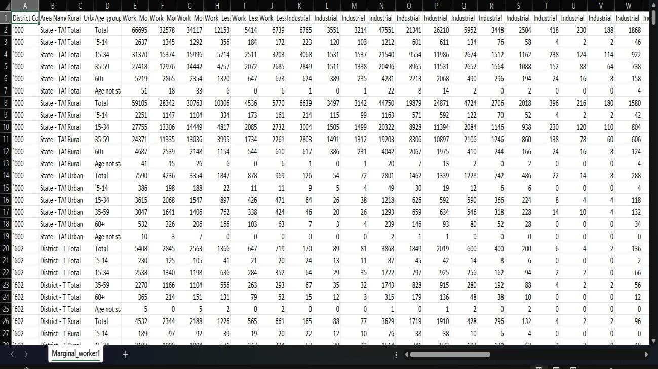

**Program:**

The program visualize the data form the given dataset. the visualization shows the relationship between the Area Code and number of workers worked in Tamil Nadu.

**Import the required modules**

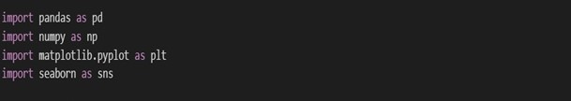

**Include the marginal worker dataset**

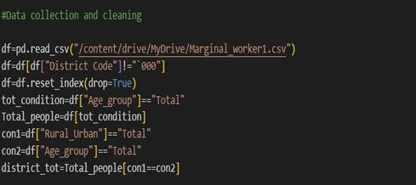

**Virtualize the relation between area code and other features**

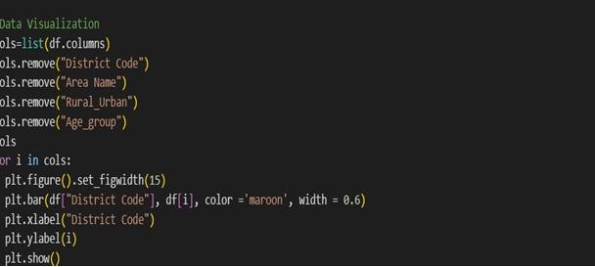

**Output of the relation in bar chart**

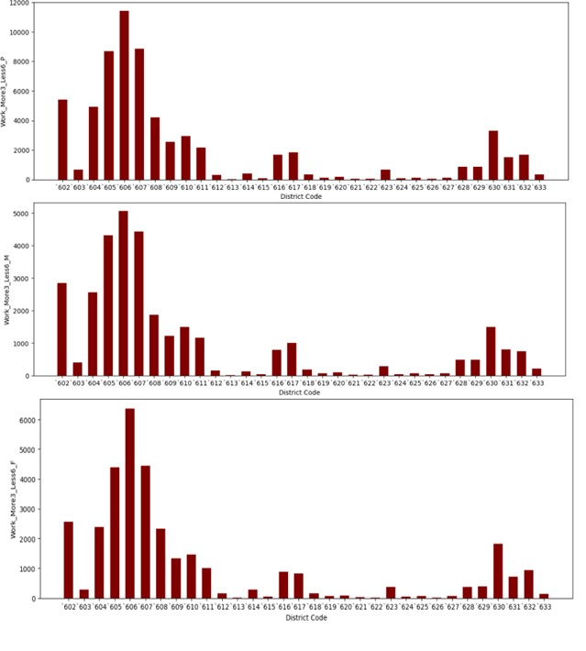

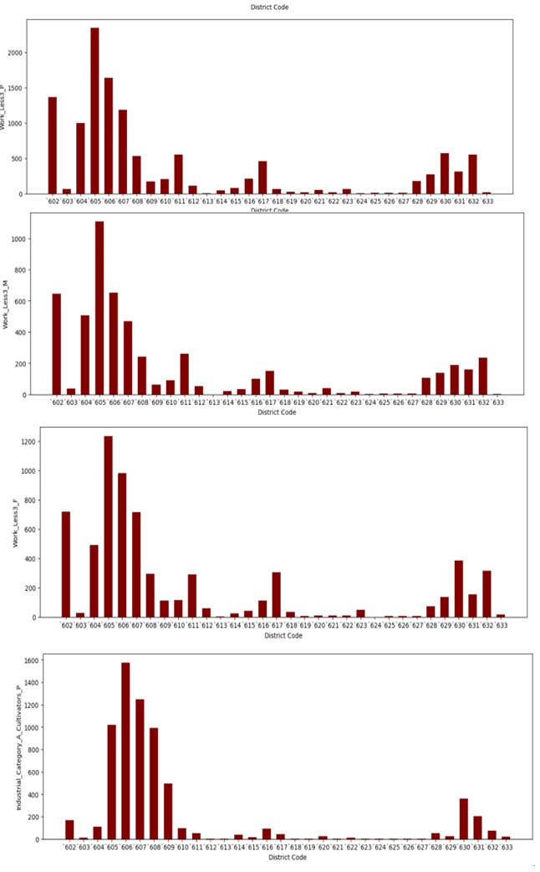 **etc**

**Correlation between two features**

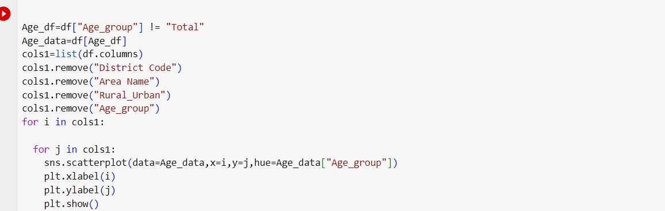

**Output 1:**

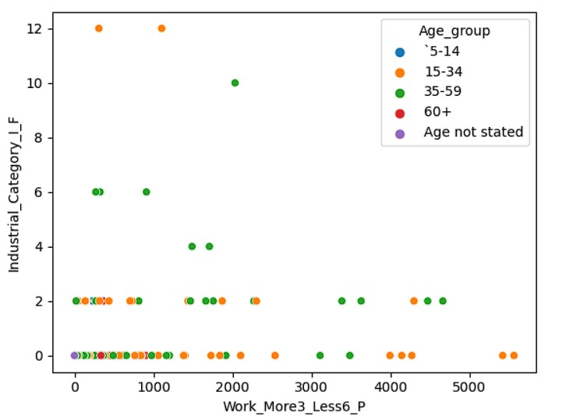

**Output 2:**

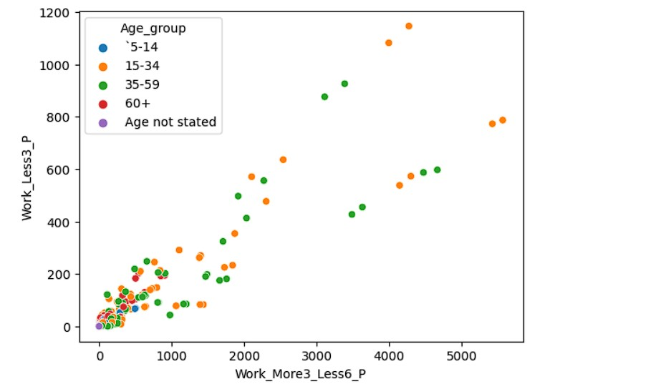

**Output 3:**

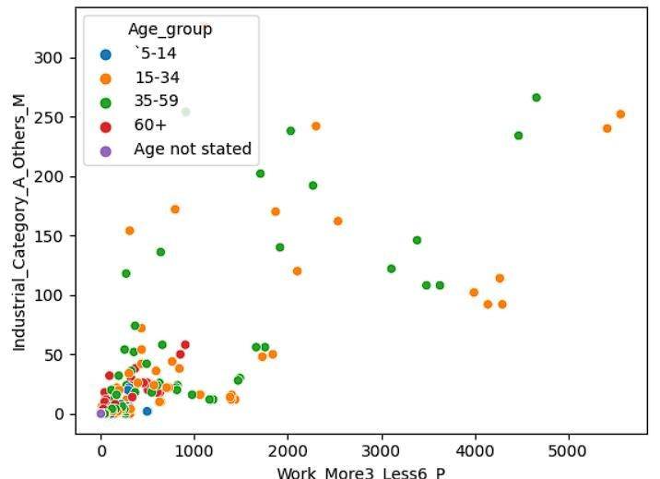

**Etc**

**Overall virtualization of the Dataset:**

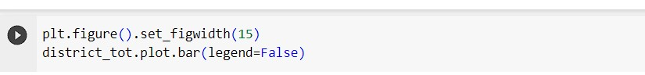

**Output:**

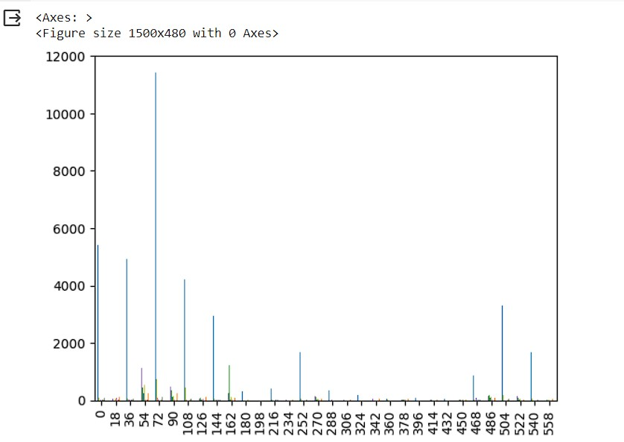

By

KISHORE.K

723721243028